**MySQL Project**

Data Story Telling



I selected the country code from the city table using the function count to show the number of cities in the table with the country code named “USA”

I selected the code, population, and average life expectancy from the country table to show the values with the code ARG (Argentina)

I selected name and life expectancy from the country table and ordered them from largest to smallest number of life expectancy but limited to show the first row which was the largest.

I selected all the values from the city table but with name column only showing names starting with the letter “F” and limited to show only the first 25 rows.

I selected id, name, and population column from the city table and limited to show only the first 10 rows.

I selected name and population column from the city table and showed the population values that are above 2000000 and ordered the show of values in descending order

I selected name column from the city table showing only the names starting with “Be”.

I selected name and population column from the city table and showed the values with population numbers being between 500000 and 1000000.

I selected name and population column from the city table and ordered the showing of the population values in ascending order (from smallest to largest) and limited to show only the first value which is the smallest number of populations.

**EER DIAGRAM**

Primary key for country is code, for countrylanguage it is Language, and for city it is ID.

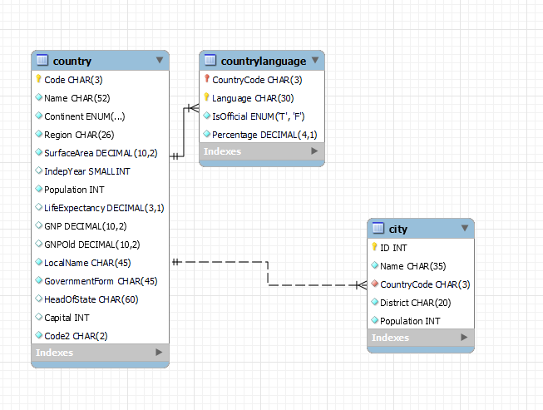Foreign key for countrylanguage is country code and for city it is countrycode